PYTHON-8 |
OOPS

Object-Oriented Programming (OOP) is a programming paradigm that organizes code into objects, each representing a real-world entity. In OOP, objects have attributes (data) and methods (functions), and they interact with each other to perform specific tasks. OOP concepts include classes, objects, inheritance, encapsulation, and polymorphism.

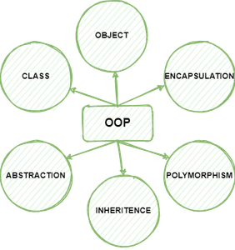

2. Class and Object:

- A class is a blueprint or a template for creating objects.

- An object is an instance of a class that encapsulates data and behavior.

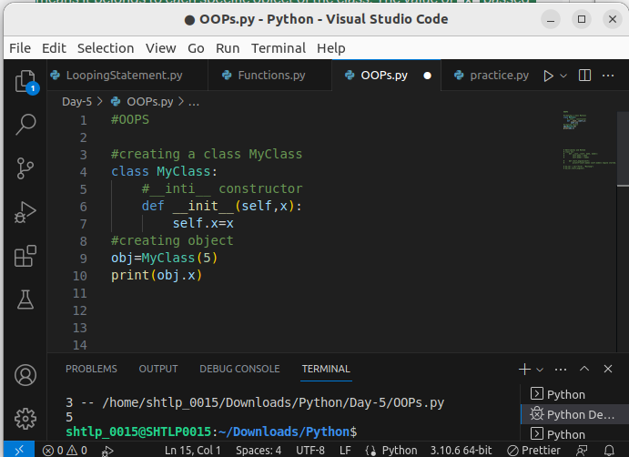

- class Myclass: This line defines the class named Myclass.

- def __init__(self, x): This is the constructor (special method) of the class. It gets called when you create an object of the class. The self parameter refers to the instance of the object being created. The x parameter is used to pass a value that will be stored in the instance variable self.x.

- self.x = x: Inside the constructor, self.x is an instance variable, which means it belongs to each specific object of the class. The value of x passed during the object's creation is assigned to self.x.

3. Attributes and Methods:
- Attributes are variables that belong to an object and store data.
- Methods are functions defined inside a class that operate on the object's data.

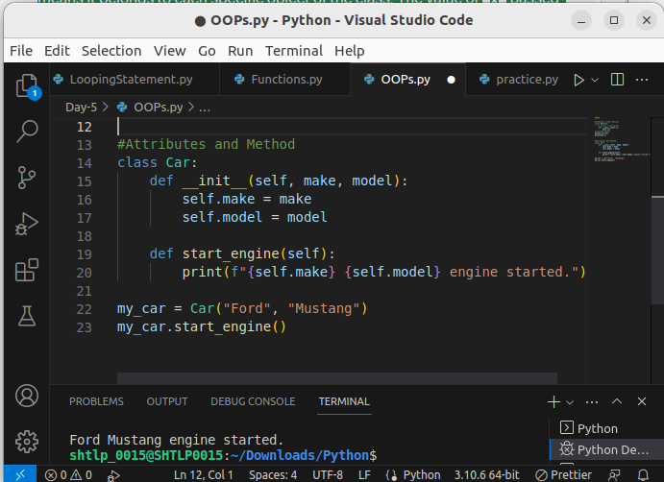
.

Note : If a class variable is changed using an object, the change will affect all objects of that class since class variables are shared among all instances. Any new object created after the change will have the updated value of the class variable, and any existing object will also reflect the updated value when accessed.

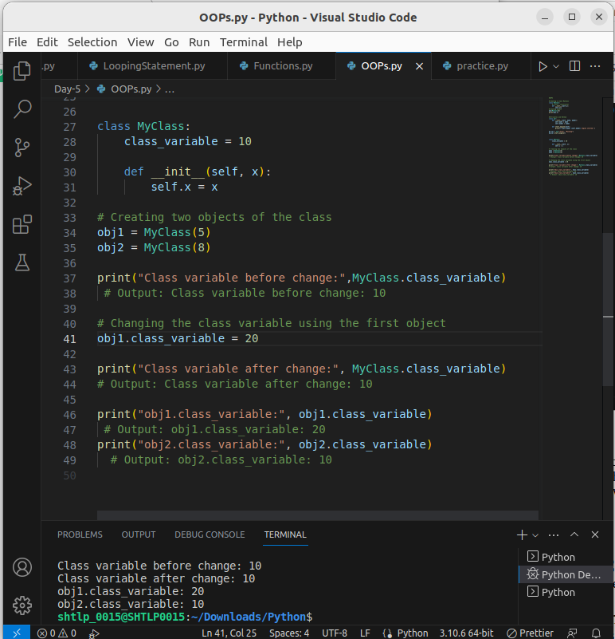

4. Constructor (__init__):
- - The `__init__` method is called when an object is created and used to initialize its attributes.

- The self parameter is a reference to the current instance of the class, and is used to access variables that belongs to the class.
- It does not have to be named self , you can call it whatever you like, but it has to be the first parameter of any function in the class
- You can delete properties on objects by using the del keyword.

5. Delete a Parameter or Object

- Delete age property: del object_name.property
- Delete Object: del object_name

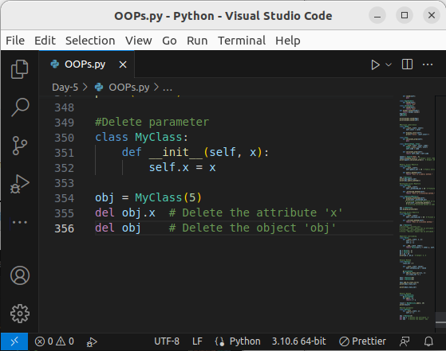
.

6. Instance and Class Variables:
- Instance variables belong to individual objects.
- Class variables are shared among all instances of a class.

- Instance variables are specific to each instance of a class. They are created for each object separately and hold data unique to that object.

- Class variables (also known as static variables) are shared among all instances of a class. They are defined at the class level and are accessible to all instances of the class.

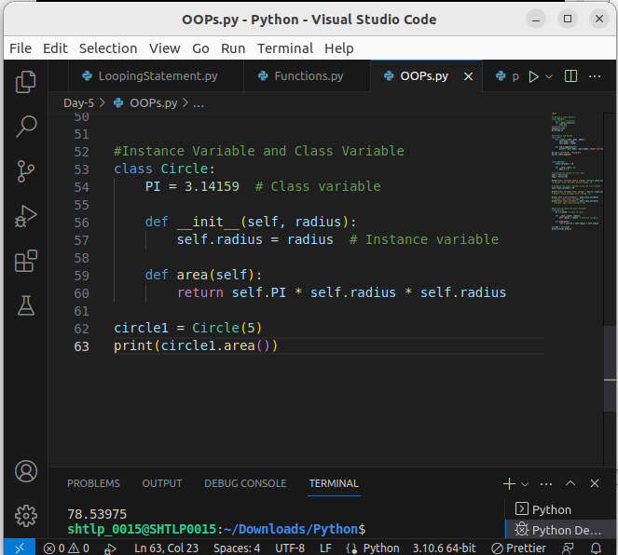

7. Access modifiers

Access modifiers are keywords used in object-oriented programming languages, including Python, to control the accessibility of class attributes and methods from outside the class. They determine which parts of a class are visible and accessible to the code outside the class. Access modifiers help in implementing the principle of encapsulation, which is an essential aspect of object-oriented programming.

In Python, there are three types of access modifiers:

1. Public Access Modifier
- Members with no access modifiers are public.
- Public members can be accessed from anywhere, both within and outside the class.
- They have no restrictions on accessibility.

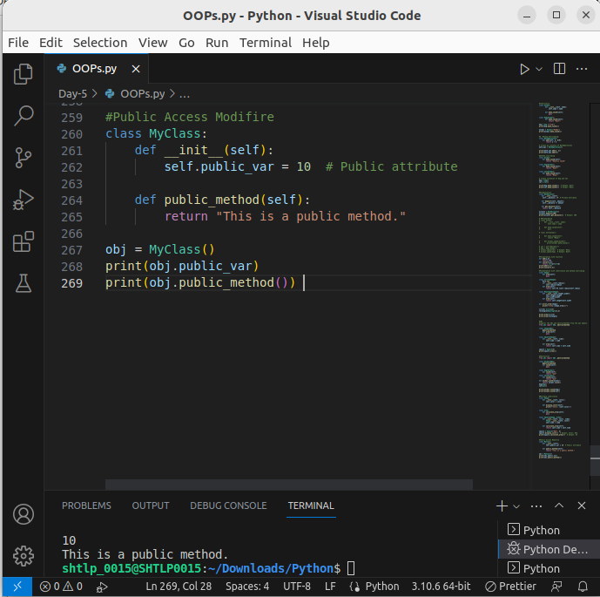

2. Protected Access Modifier:
- Members with a single leading underscore (e.g., `_protected_var`) are considered protected.
- Protected members can be accessed within the class and its subclasses (derived classes).
- They are intended to indicate that the member should not be accessed from outside the class or its subclasses, but it's not enforced by the language.

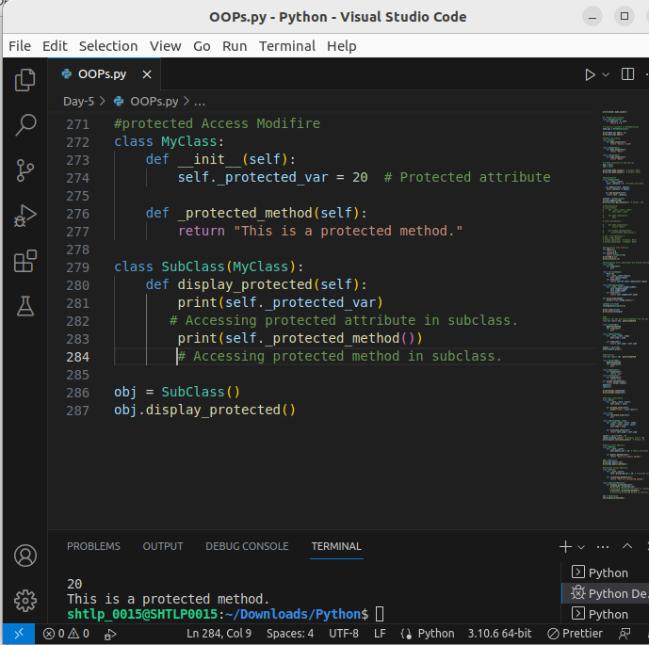

3. Private Access Modifier:
- Members with double leading underscores (e.g., `__private_var`) are considered private.
- Private members can be accessed only within the class itself, not from outside the class.
- They are intended to indicate that the member should not be accessed directly by anything outside the class, and it's enforced by the language using name mangling.

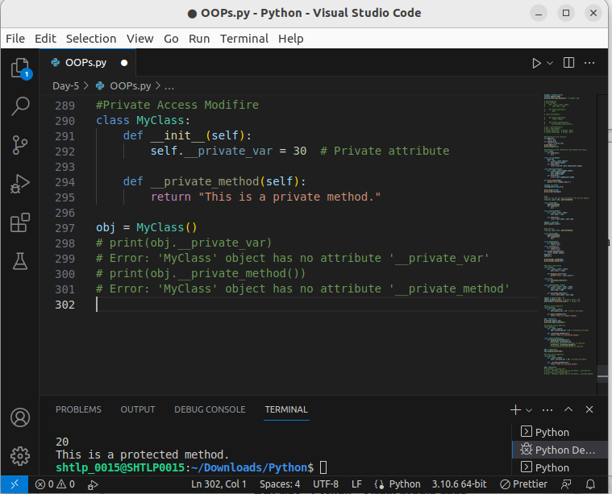
In this example, `__private_var` and `__private_method()` are private members of the `MyClass` class and cannot be accessed directly from outside the class. However, they can be accessed within the class itself using the modified names (name mangling).

8. Class Methods

Class methods are methods bound to the class and not the instance. They are defined using the `@classmethod` decorator and take the class (`cls`) as their first parameter instead of the instance (`self`).

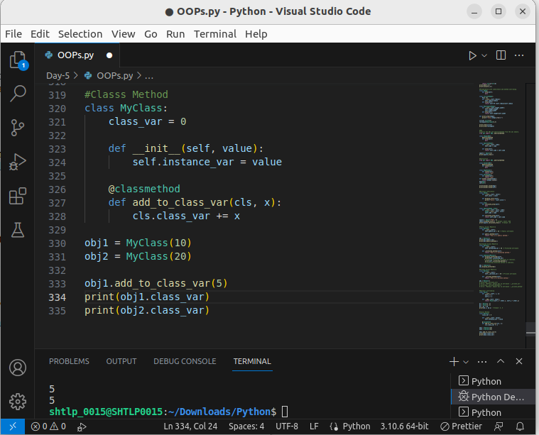

In this example, the `add_to_class_var()` is a class method that increments the class variable `class_var`. The method is called on the class `MyClass`, and any changes to the class variable are reflected in all instances of the class.

9.Static Methods

Static methods are class-level methods that do not operate on instance-specific data. They are defined using the `@staticmethod` decorator and do not require access to the instance (`self`) or class (`cls`) as their first parameter.

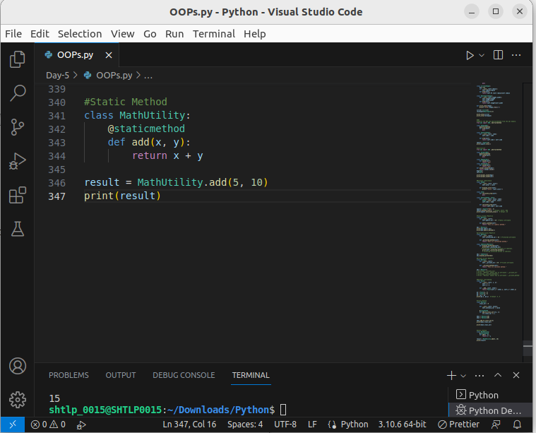

Certainly! Here are three advantages of static methods in Python:

1.No Access to Instance or Class-specific Data: Static methods do not require access to instance-specific or class-specific data. They work independently and are not tied to the state of the object or the class, making them suitable for utility functions.

2. Improved Code Organization: Static methods help in improving code organization by grouping related functionality within the class. They are explicitly marked as static using the `@staticmethod` decorator, making their purpose clear.

3. Code Reusability: Static methods promote code reusability by allowing you to define common operations or calculations that can be used across multiple classes. Since they are not tied to specific instances, they can be shared among different classes.

10. Inheritance:

- Inheritance allows one class (subclass) to inherit attributes and methods from another class (superclass).
- Inheritance allows us to define a class that inherits all the methods and properties from another class.
Parent class is the class being inherited from, also called base class.
Child class is the class that inherits from another class, also called derived class.

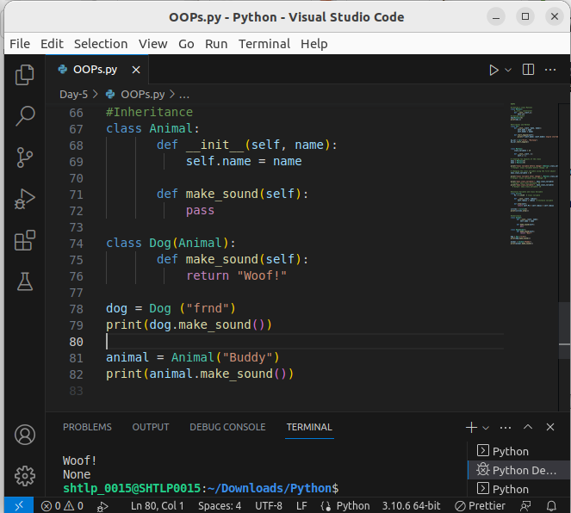
- class Animal : defines the base class named `Animal`.

- def __init__(self, name): This is the constructor (special method) of the class `Animal`. It gets called when you create an object of the class. The `self` parameter refers to the instance of the object being created, and `name` is the parameter used to pass a value for the `name` attribute of the animal.

- self.name = name: Inside the constructor, `self.name` is an instance variable that holds the value passed during the object's creation. It represents the name of the animal.

- def make_sound(self): This is a method defined within the `Animal` class. It is a placeholder method as it doesn't have any implementation (no code inside the method body). We use the `pass` statement to indicate that the method has no code but is defined for future use.

Next, we define a derived class `Dog`, which inherits from the `Animal` class:

- class Dog(Animal) : This line defines the derived class named `Dog`, which inherits from the `Animal` class. By specifying `(Animal)` after the class name, we indicate that `Dog` inherits all the attributes and methods from the `Animal` class.

- def make_sound(self) : Inside the `Dog` class, we define a `make_sound()` method. This method overrides the `make_sound()` method of the `Animal` class. This is an example of method overriding, where a subclass provides its implementation of a method with the same name as the one in the superclass.

- return "Woof! “ In the `make_sound()` method of the `Dog` class, we return the string "Woof!" to indicate the sound a dog makes.

- Now, let's create an object of the `Dog` class named `dog`:
dog = Dog("Buddy")

- An instance of the `Dog` class is created with the name "Buddy."

- Finally, we call the `make_sound()` method on the `dog` object and print its result:
print(dog.make_sound())

- print(dog.make_sound()) :This line calls the `make_sound()` method on the `dog` object. Since `Dog` has overridden the `make_sound()` method from `Animal`, it will use the implementation from the `Dog` class, and the output will be:

- Woof!

- This indicates that the `make_sound()` method from the `Dog` class was called, and it returned the string "Woof!"

11. Types of Inheritance:
Inheritance is a key concept in object-oriented programming (OOP) that allows a class to acquire the properties and behaviors of another class. In Python, there are different types of inheritance based on the number of parent classes and the hierarchy of inheritance.

1. Single Inheritance:

Single inheritance is the most basic form of inheritance, where a class inherits from only one parent class. A subclass can have only one direct ancestor class, and it inherits the attributes and methods of that class.

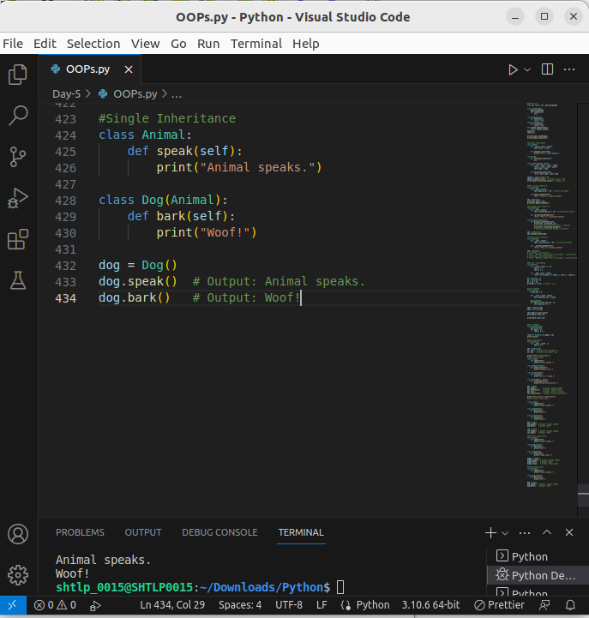

2. Multi-level Inheritance:

Multi-level inheritance involves a chain of inheritance, where a subclass inherits from another subclass, which in turn inherits from its own parent class. In this type of inheritance, the classes are organized in a linear order.
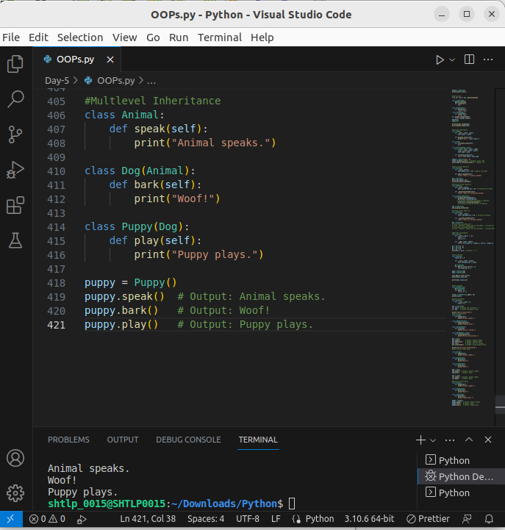

3. Hierarchical Inheritance:

Hierarchical inheritance involves multiple subclasses inheriting from the same parent class. In this type of inheritance, one parent class has multiple child classes, and each child class inherits the properties and behaviors of the same parent class.

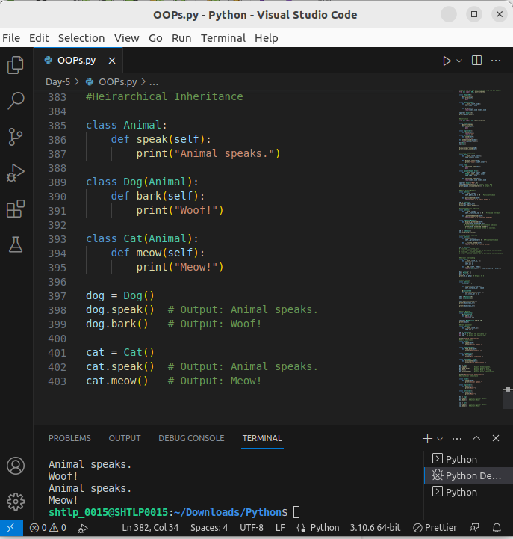

4. Multiple Inheritance:
- A class can inherit from multiple superclasse s.
Multiple inheritance is a feature in object-oriented programming (OOP) that allows a class to inherit attributes and behaviors from more than one base class. In other words, a single class can be derived from multiple parent classes, and it can access and use the methods and attributes of all its parent classes.

In Python, multiple inheritance is achieved by specifying multiple base classes separated by commas in the class definition. The order of base classes in the class definition matters because it determines the method resolution order (MRO) when calling methods that have the same name in multiple base classes.

Let's see an example of multiple inheritance:

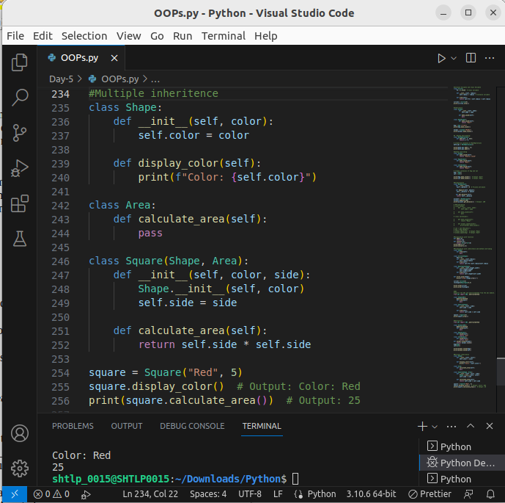

In this example, we have three classes: `Shape`, `Area`, and `Square`.

- The `Shape` class defines an attribute `color` and a method `display_color()` to display the color.

- The `Area` class has a method `calculate_area()` that doesn't have an implementation (indicated by `pass`). This class acts as a placeholder for other classes to define their own area calculation.

- The `Square` class is derived from both `Shape` and `Area` classes using multiple inheritance. It inherits attributes and methods from both classes.

When we create an instance of the `Square` class, we pass the color and side length as arguments to the constructor. The `Square` class overrides the `calculate_area()` method from the `Area` class to provide its implementation for calculating the area of a square.

By using multiple inheritance, the `Square` class now has access to both the color attribute from the `Shape` class and the `calculate_area()` method from the `Area` class.

It's important to use multiple inheritance judiciously as it can lead to complex code and potential conflicts when methods have the same name in multiple base classes. Care should be taken to avoid diamond inheritance, where a class inherits from two classes that have a common base class, to prevent ambiguity in method resolution order.

5. Hybrid Inheritance:

Hybrid inheritance is a combination of multiple inheritance and single inheritance. It involves a class inheriting from both single parent classes and multiple parent classes. It is a mix of different types of inheritance.

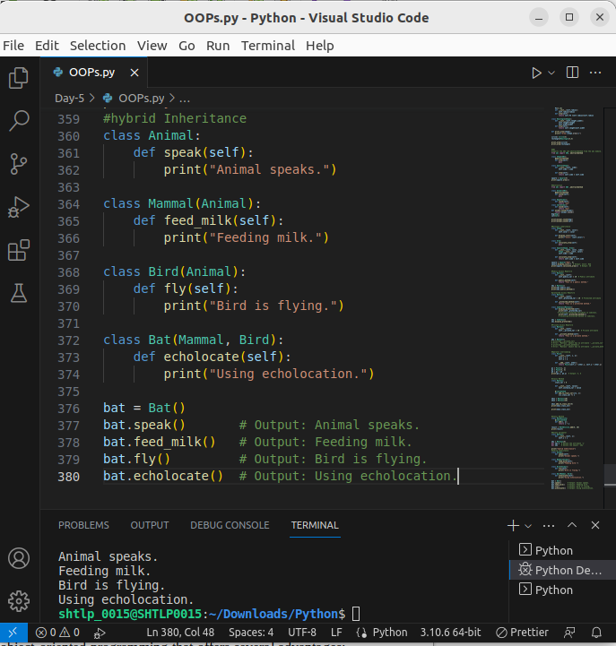

In this example, the class `Bat` inherits from both `Mammal` and `Bird`, which demonstrates hybrid inheritance. `Mammal` and `Bird` classes, in turn, inherit from the `Animal` class, making it hierarchical inheritance as well.

12. Advantages of Inheritance:

Inheritance is a powerful concept in object-oriented programming that offers several advantages:

1. Reusability:
Inheritance allows you to reuse code from existing classes, promoting code reuse and reducing redundancy. By inheriting attributes and methods from a parent class, a subclass can leverage the functionality of the parent class without having to rewrite it. This not only saves development time but also helps in maintaining a clean and modular codebase.

2. Code Modification:
Inheritance provides a convenient way to modify or extend the behavior of existing classes. When you need to make changes to a class, you can do so in the parent class, and those changes will automatically apply to all its subclasses. This reduces the need to modify multiple classes individually, making code maintenance more efficient.

3. Extensibility:
Inheritance allows you to create new classes that are specialized versions of existing classes. You can add new attributes and methods specific to the subclass while inheriting the common attributes and methods from the parent class. This allows you to extend the functionality of a class without altering the original implementation, promoting code extensibility.

4. Data Hiding:
Inheritance, when combined with access modifiers (e.g., public, protected, private), supports data hiding and encapsulation. You can use access modifiers to control the visibility and accessibility of attributes and methods. This helps in hiding the internal implementation details of a class from external code, ensuring that the class's data remains secure and not subject to direct manipulation.

5. Polymorphism:
Inheritance facilitates polymorphism, another essential feature of OOP. Polymorphism allows objects of different classes to be treated as objects of a common superclass. This means that a function or method can work with objects of various subclasses, as long as they share a common interface defined by the superclass. Polymorphism enhances code flexibility and makes it easier to write generic code that operates on different object types.

